Ti riporto di seguito i grafici dalle simulazioni con B = 64 ripetizioni sul cluster. I dati simulati sono di questo tipo:

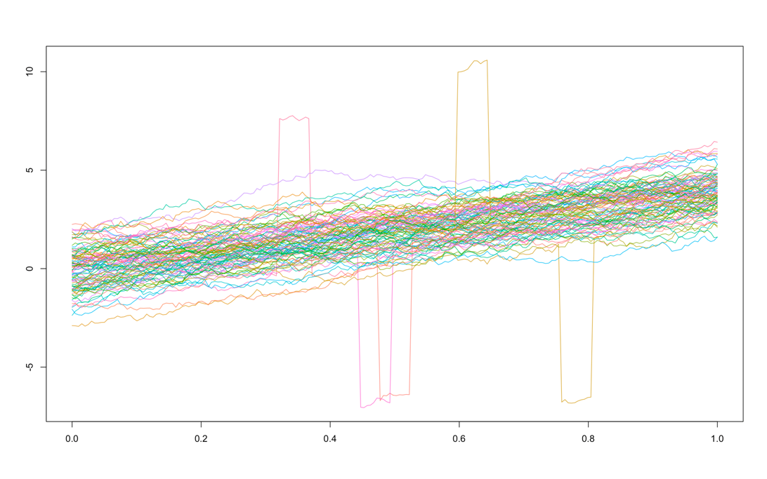

E qui i soliti grafici:

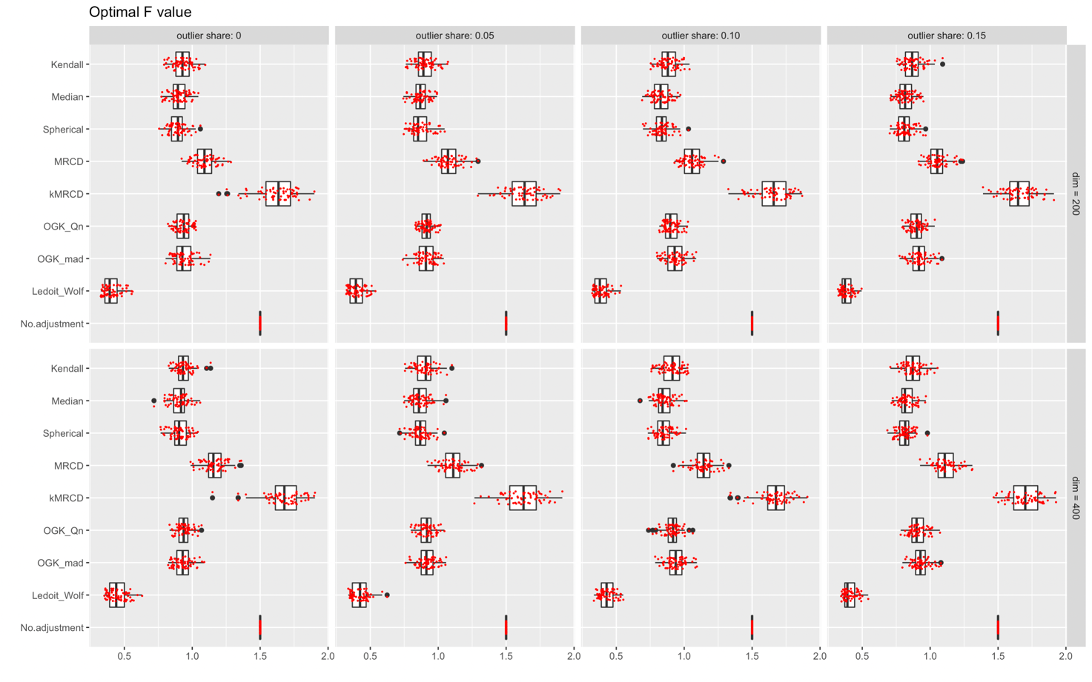

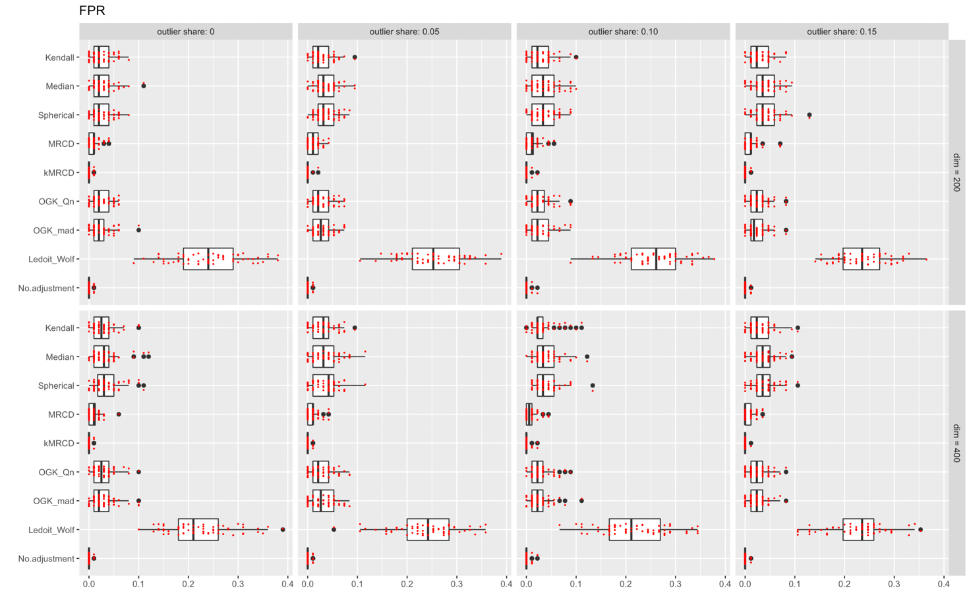

Come vedi, il FPR si comporta come al solito. Sul TPR invece ci sono molti problemi. “Incredula” ho fatto qualche prova in locale per plottare i dati e vedere cosa facesse, perché mi sembravano quasi banali da identificare. Di seguito qualche esempio:

Senza aggiustamento con 5% outliers:

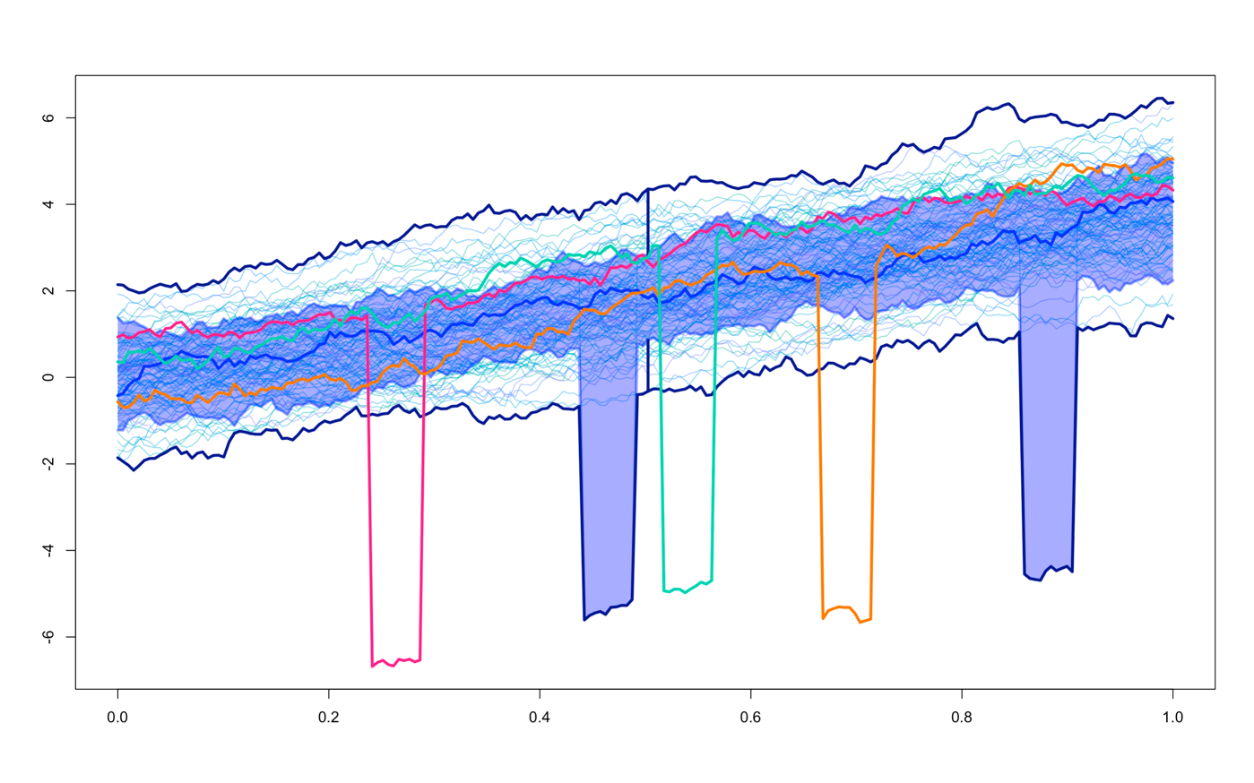

Spherical con 5% outliers:

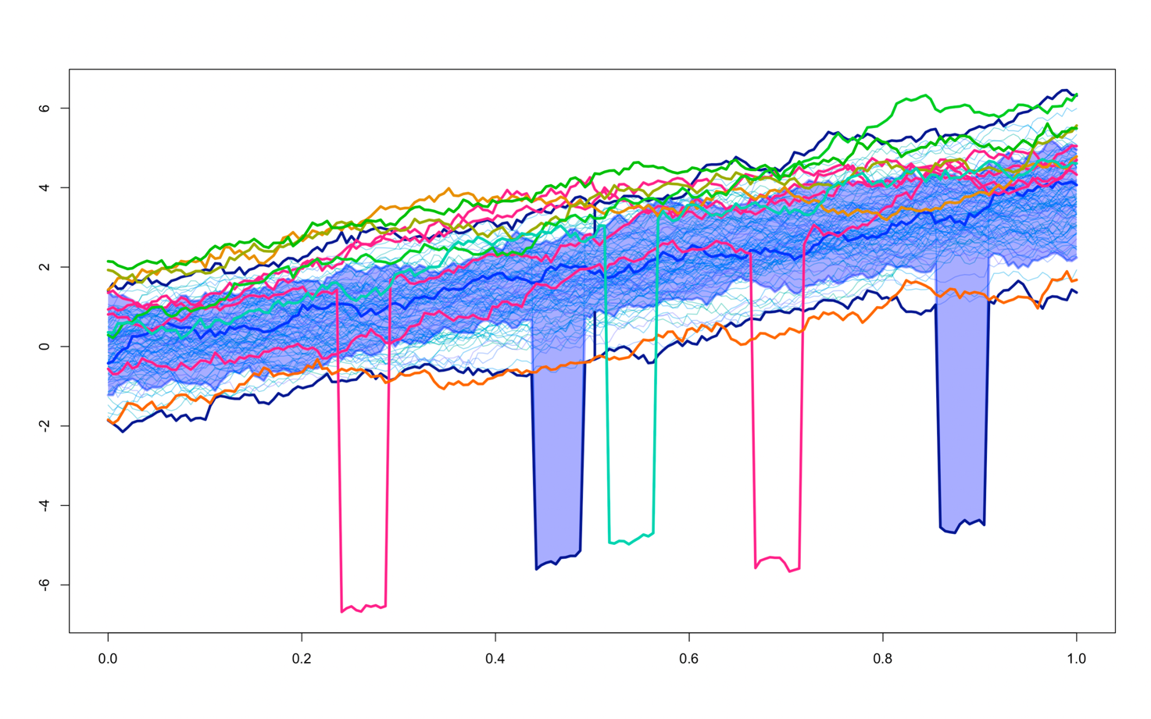

Spherical con 15% outliers:

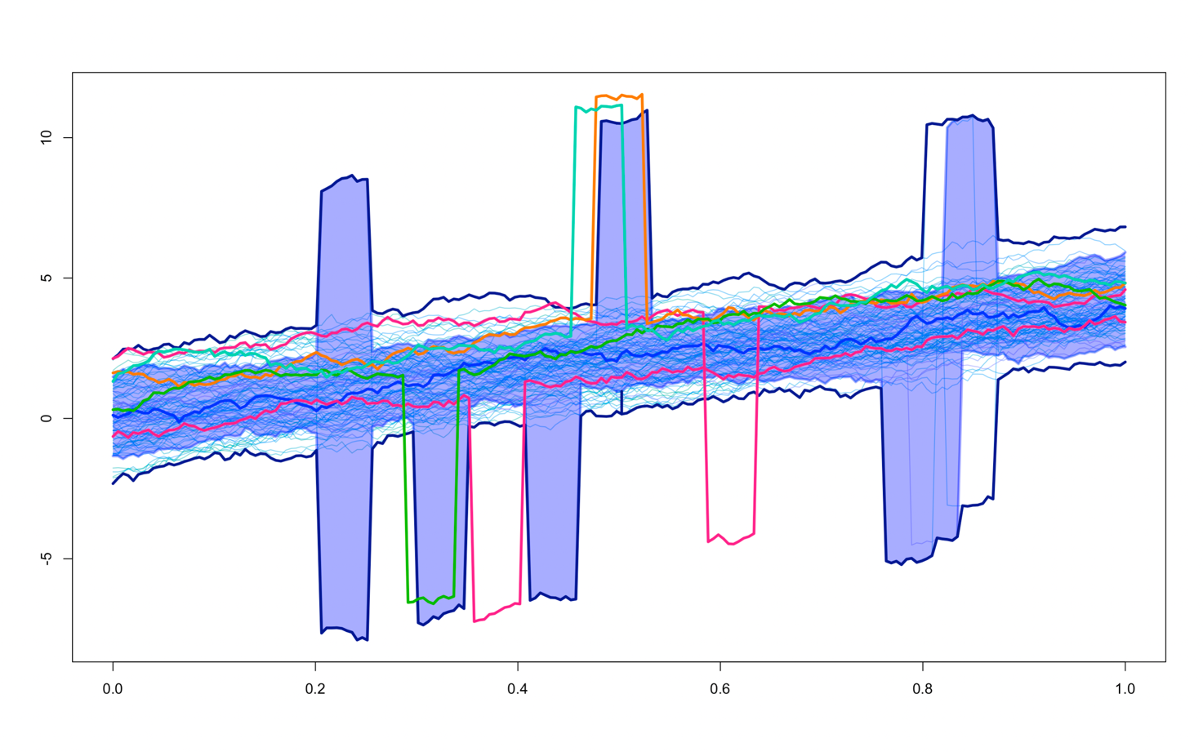

COMMENTS:

…Talk about the generation of isolated outliers…

The simulation pertaining isolated outliers over the domain did not produce relevant results. As these samples have a noticeable out-of-bag behavior, we were expecting even the easiest of these methods to identify the majority of them. However, with or without the adjustment procedure implemented, we were not able to flag all outlying observations as such, and also many false positive arose. Due to this unforeseen outcome, we carried a deeper examination of the depths used in the functional boxplot, which might be the cause. Since the measures already provided by the \texttt{roahd} CRAN package, namely Band Depths and their modified version, didn’t lead to satisfying results, we tried the functional depths supplied by the \texttt{fda.usc} package, to understand how they could differ from the previous. After converting our functional object to the one introduced in \texttt{fda.usc}, some trials were done manually to understand the potential discrepancy among different computations. With a small simulation conducted locally only in the case of non-adjusted functional boxplot, evidence is for the Modal depths (see Cuevas et al 2007) among the many tried (RT, FSD, KFSD, RP, RPD) to be the best at spotting spikes.

It calculates the depth of a datum accounting the number of curves in its neighbourhood. By default, the distance is calculated using metric.lp function.

Figure … shows one realization of the contamination process outlined above, with grayscale palette to give an idea of the depth of each observation. Figure … a) is obtained thanks to the modified band depth computation of the package \texttt{depthTools}. Note that the two plots use the grayscale in different manners: \texttt{fda.usc} colors inliers with black, while \texttt{depthTools} colors them in white. Despite this, is very clear from Figure … that the Modal depth is able to recognize all isolated outliers as those which are rarely inside the bands of the other curves, while MBD struggles in this task.

Even if we modified the current version of the functional boxplot to account for other implementations of the depth measures, this procedure requires an unfeasible computational time. The Modal depth is also the fastest among the ones provided, but despite this a complete simulation study, with the adjustment procedures explored in this paper, which exploits it is not reasonable. A more computationally efficient version of this algorithm should be implemented to allow for such study.

